Steps to use github

Step1 : & git add .

Step2 : & git commit -m” You can write anything”

Step3 : & git push origin

Steps to Use OpenSSH to Generate an SSH Key Pair

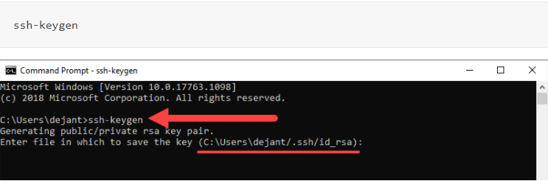

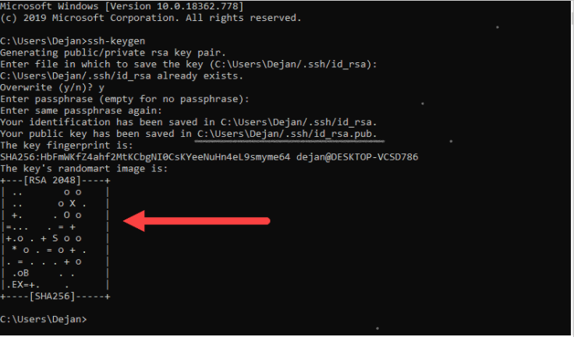

Copy Your public key has been saved in.

Step2 : Window + E in smd copy link



Step 3: Copy link Your identification has been save paste link in



Step 4: Run with Notpad and copy it

Step 5:

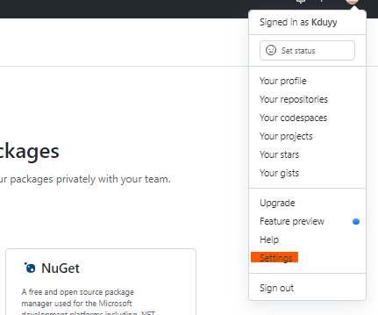

Step 6:



Step 7: paste link

